**PROJECT REPORT**

**ON**

**“Tourism Management System”**

**Submitted In Partial Fulfillment of the Requirement**

**For The Award of**

**MASTER IN COMPUTER APPLICATION**

**P.E.S MODERN COLLEGE OF ENGINEERING PUNE – 411 005.**

**AFFILIATED TO**

**SAVITRIBAI PHULE PUNE UNIVERSITY**

**Submitted By**

Kagade Laxman

Ahirrao Kalpesh

Shinde Hanumant

**Under the Guidance of**

**Dr. Prakash Kene**



**Progressive Education Society’s**

**Modern College of Engineering, Pune- 411005**

**MCA Department 2021-22**

**Progressive Education Society’s**

**Modern College of Engineering, Pune - 411005**

**MCA Department**

**CERTIFICATE**

This is to certify that “**Kagade Laxman , Ahirrao Kalpesh , Shinde Hanumant”** of Master in computer Application have successfully completed the Project Based Learning work titled **“Tourism Management System”** during the academic year 2021-22.This report is submitted as partial fulfillment of the requirement of the said subject of Savitribai Phule Pune University.

**Dr. Mrs. K. R. Joshi Dr. Pradnya Muley Dr. Prakash Kene**

**Principal Head of Department Project Guid**

**ACKNOWLEDGEMENT**

We wish to express our sense of gratitude to our respected guide **Dr. Prakash Kene** for his valuable guidance and kind cooperation in the success of Project demo.

We also extend our thanks to respected **Prof. Shipad S. Bhide** and **Prof. Rama Bansode** and all our teachers and staff of MCA dept. For timely help in the course of Project preparation.

My co-ordinal thanks to our Head of Department(HOD) **Dr.Pradnya Muley** and all those who contributed their sincere cooperation directly or indirectly and material help in works or needs for preparation of this project.

**52130 - Kagade Laxman**

**52105 - Ahirrao Kalpesh**

**52164 - Shinde Hanumant**

**SY-MCA**

**INDEX**

| Content | Page No. |
| --- | --- |
| * Introduction | 4 |
|  |  |
| * Objective | 5 |
|  |  |
| * Existing System | 5 |
|  |  |
| * Proposed System | 5 |
|  |  |
| * Study of the System | 6 |
|  |  |
| * Functional Requirement | 9 |
|  |  |
| * System Environment | 11 |
|  |  |
| * DFD Diagrams | 12 |
|  |  |
| * UML Diagrams | 16 |
|  |  |
| * ER Diagrams | 19 |
|  |  |
| * Database Design | 20 |
|  |  |
| * Output Screen of the Project (Screenshots) | 23 |
|  |  |
| * Conclusion | 35 |
|  |  |
| * Bibliography | 36 |

**INTRODUCTION**

* Tourism management system is used to book a tour from anywhere in the world by a single dynamic website which will help the user to know all about the places and tour details in a single website.

* The admin can add packages to the website from a certain travel agents and hotels by create a tour page. Then the users can sign in and book each project, they can be confirmed by the admin in their manage booking page. The user can see the confirmation in their my booking page. It is a easiest platform for all travelers which can be easily booked and know the all details.
* Tourism Management system is a dynamic website for tourism business. It is dynamic and responsive web design. It is also called travel technology solution for agencies & tour operation. Nearly Everyone goes on a vacation for this a ‘Tourism management system’ would play a vital role in planning the perfect trip.
* The tourism management system allows the user of the system access all the details such as location, events, etc. The main purpose is to help tourism companies to manage customer and hotels etc. The system can also be used for both professional and business trips.

**OBJECTIVE:**

* The objective of the project is to develop a system that automates the processes and activities of a travel and tourism agency.
* The purpose is to design a system using which one can perform all operations related to traveling and sight-seeing.

**EXISTING SYSTEM:**

* In the present system a customer has to approach various agencies to find details of places and to book tickets.
* This often requires a lot of time and effort.
* A customer may not get the desired information from these offices and often the customer may be misguided.
* It is tedious for a customer to plan a particular journey and have it executed properly.

**PROPOSED SYSTEM:**

* The proposed system is a web based application and maintains a centralized repository of all related information.
* The system allows one to easily access the relevant information and make necessary travel arrangements.
* Users can decide about places they want to visit and make bookings online for travel and accommodation.

# **STUDY OF THE SYSTEM:**

To provide flexibility to the users, the interfaces have been developed that are accessible through a browser. The GUI’S at the top level have been categorized as

1. Administrative user interface
2. The operational or generic user interface

The ‘administrative user interface’ concentrates on the consistent information that is practically, part of the organizational activities and which needs proper authentication for the data collection. These interfaces help the administrators with all the transactional states like Data insertion, Data deletion and Date updation along with the extensive data search capabilities.

The ‘operational or generic user interface’ helps the end users of the system in transactions through the existing data and required services. The operational user interface also helps the ordinary users in managing their own information in a customized manner as per the included flexibilities.

**FEASIBILITY STUDY:**

**FEASIBILITY REPORT:**

Preliminary investigation examines project feasibility; the likelihood the system will be useful to the organization. The main objective of the feasibility study is to test the Technical, Operational and Economical feasibility for adding new modules and debugging old running system. All systems are feasible if they are given unlimited resources and infinite time. There are aspects in the feasibility study portion of the preliminary investigation:

* Technical Feasibility
* Operation Feasibility
* Economical Feasibility

**TECHNICAL FEASIBILITY:**

The technical issue usually raised during the feasibility stage of the investigation includes the following:

* Does the necessary technology exist to do what is suggested?
* Do the proposed equipments have the technical capacity to hold the data required to use the new system?
* Will the proposed system provide adequate response to inquiries, regardless of the number or location of users?
* Can the system be upgraded if developed?
* Are there technical guarantees of accuracy, reliability, ease of access and data security?

**OPERATIONAL FEASIBILITY:**

Proposed projects are beneficial only if they can be turned out into information systems, which will meet the organization’s operating requirements. Operational feasibility aspects of the project are to be taken as an important part of the project implementation. Some of the important issues raised are to test the operational feasibility of a project includes the following: -

* Is there sufficient support for the management from the users?
* Will the system be used and work properly if it is being developed and implemented?
* Will there be any resistance from the user that will undermine the possible application benefits?

This system is targeted to be in accordance with the above-mentioned issues. Beforehand, the management issues and user requirements have been taken into consideration. So there is no question of resistance from the users that can undermine the possible application benefits.

The well-planned design would ensure the optimal utilization of the computer resources and would help in the improvement of performance status.

**ECONOMIC FEASIBILITY:**

A system can be developed technically and that will be used if installed must still be a good investment for the organization. In the economical feasibility, the development cost in creating the system is evaluated against the ultimate benefit derived from the new systems. Financial benefits must equal or exceed the costs. The system is economically feasible. It does not require any additional hardware or software.

# **FUNCTIONAL REQUIREMENTS:**

# **Number of Modules**

After careful analysis the system has been identified to have the following modules:

1. **Administrator module**
2. **User(Traveler) module**
3. **Guest user**
4. **ADMINISTRATOR MODULE:**

This module provides administrator related functionality. Administrator manages all information and has access rights to add, delete, edit and view the data related to places, travels, routes, bookings, Enquiries etc.

**Packages—**Admin will create the packages and Manage the packages(Create,Update,delete)

**Users-** Admin views all Information of all users.

**Booking-** Admin will responsible for manage booking. Admin can confirm and cancel a booking of traveler.

**Manage issues/ Complaints**—Admin can take action on any issue /complaint raised by user (traveller) and Put remark.

**Manage Enquiries—**admin can manage all enquiries raised by users(traveller).

**Manage pages-** Admin can edit the info of all pages that are display on the website,

**Dashboard-** Here admin can view all count of booking, issues , Enquiries and Users .

**Change password---** Admin can change own password.

1. **USER(TRAVELLER) MODULE:**

**Signup-** User can register your self for bookig.

**Sign in-** Here user can login with valid username and password.

**Forgot Password—**User can recover his/her own password.

**My Profile-** user can update own profile.

**Tour history-**After login user can book any tour that will show in Tour history. User can cancel his/her booking before 24 hr of travelling.

**Change Password---- User can own Password.**

**Write-use—Here user can raise any issue related to booking. Cancelation etc.**

**3.Guest MODULE:**

Guest user can visit the website and view the all content of website. Guest user can also Enquiry.

**SYSTEM ENVIRONMENT**

**2.1 Hardware Configuration**

* Intel CORE i3 or higher.
* 512 MB RAM
* 40GB HDD
* 1024 * 768 Resolution Color Monitor

**2.2 Software Configuration**

* 1. OS : Windows 7, 10.
* 2. PHP.
* 3. HTML, CSS, Javascript.
* 4. Database: MySql.
* 5. Editor: Notepad, Visual Studio Code, Sublime Text.

**DFD (Context level Diagram):**

1. **Users**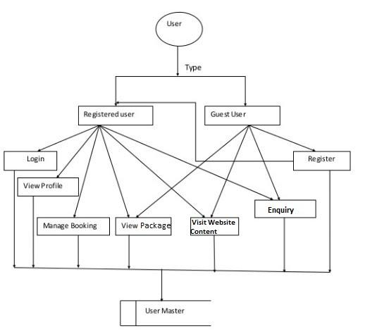
2. **Admin**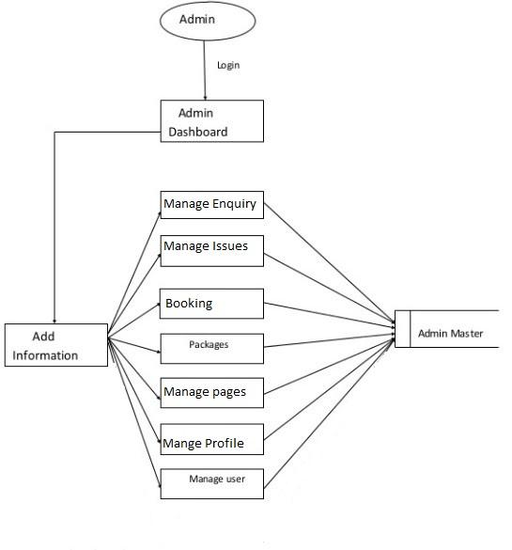

**c. System**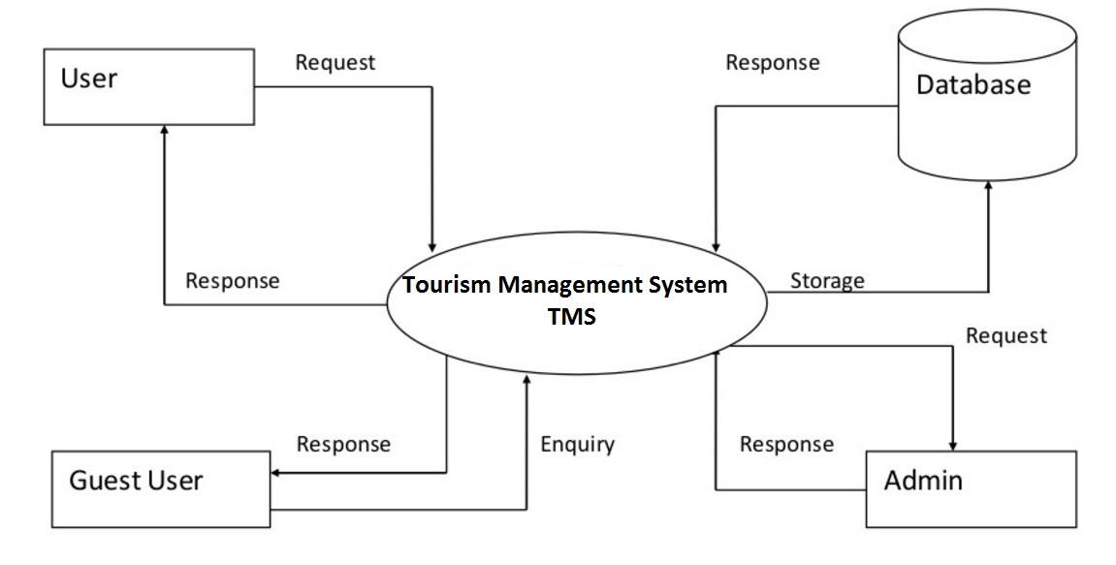

**d. Package**

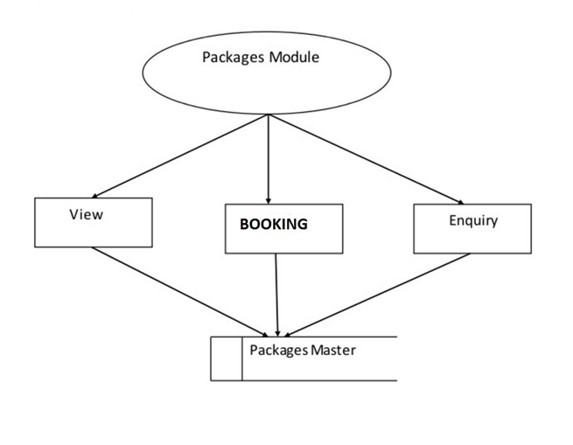

**UML Diagram**

**Use Case Diagram:**

**Admin :** 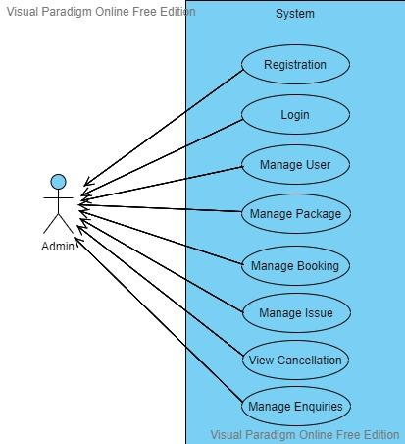

**User:**

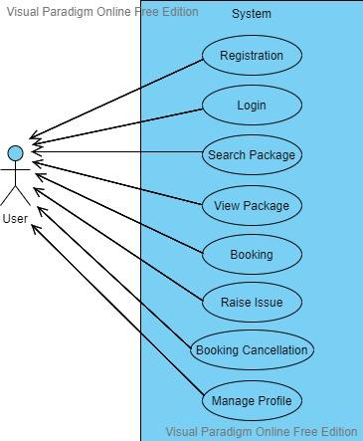

**Class Diagram**

The class diagram shows a set of classes, interfaces, collaborations and their relationships.

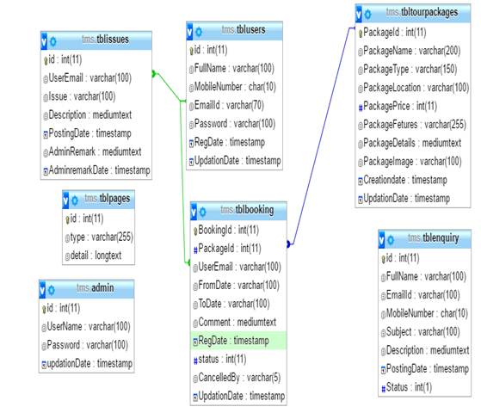

#### ENTITY-RELATIONSHIP DIAGRAM

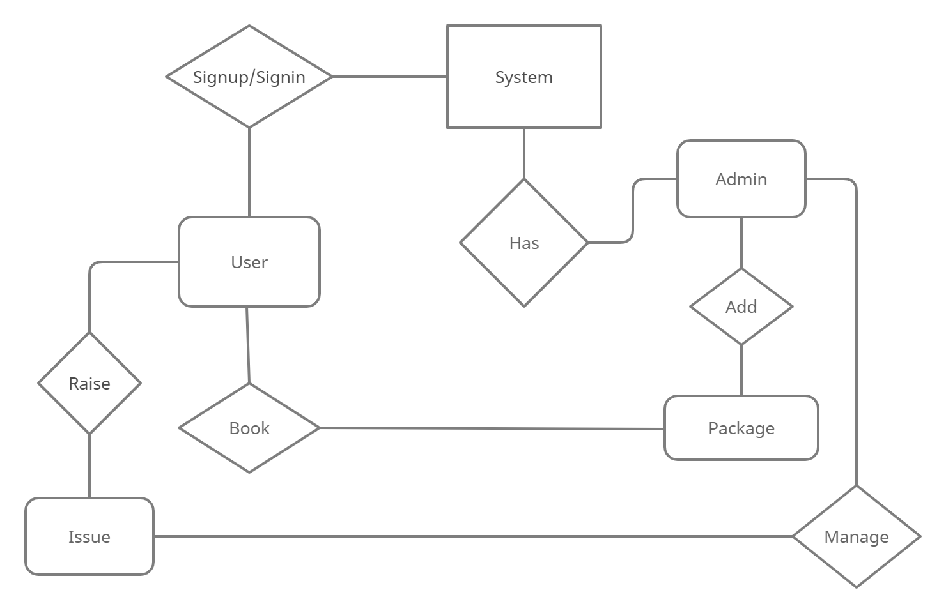

**Database Design**

**Database tables and Structure**

**Admin Table:** This table store the admin login details.

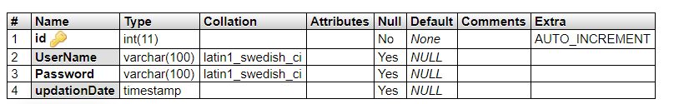

**tbluser table:** This table store the user personal and login details.

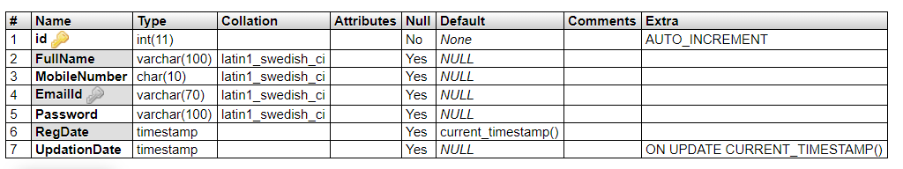

**tbltourpackages table:** This table store the tour package full details.

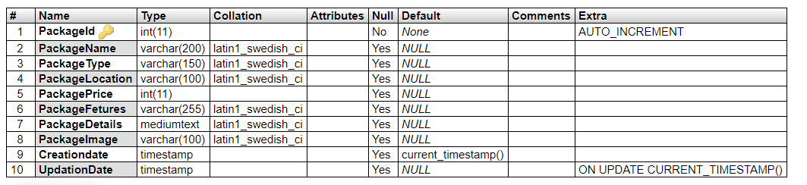

**tblbooking table:** This table store the user booking details.

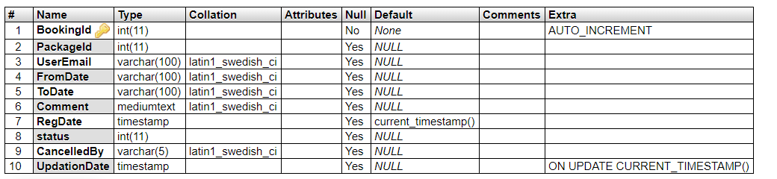

**tblissues table:** This table store the user issue details raised by the user.

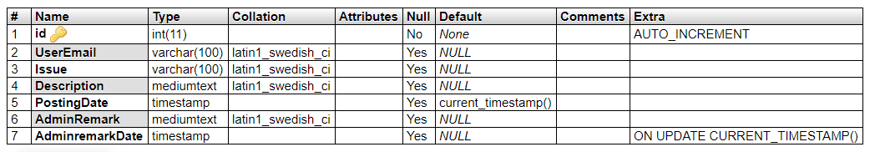

**tblenquiry table:** This table store the user enquiry details.

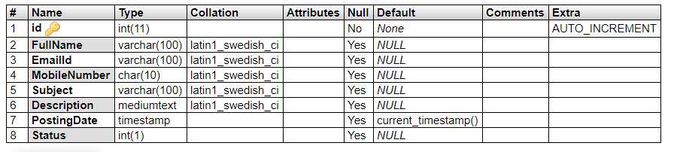

**tblpages table:** This table store the website pages details.

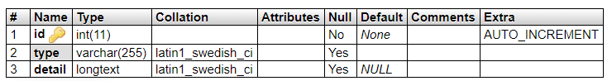

**Output Screen of Project**

**Home Page**

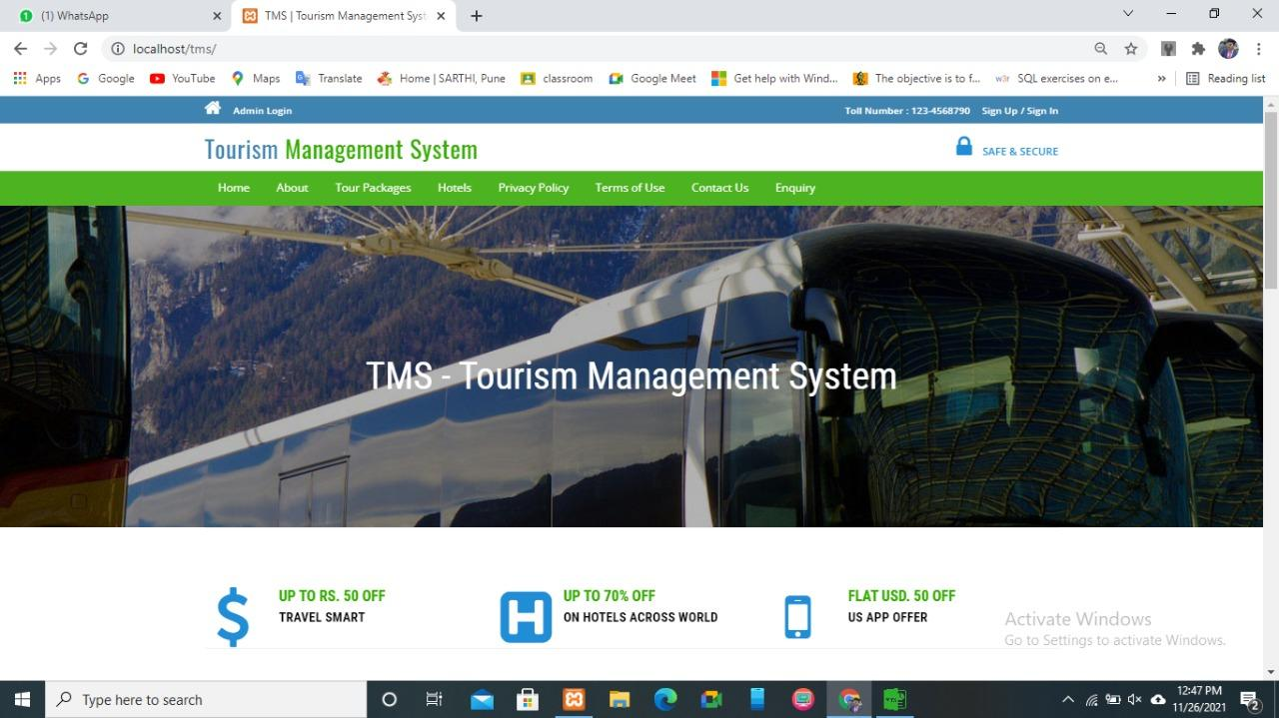

**About Us Page**

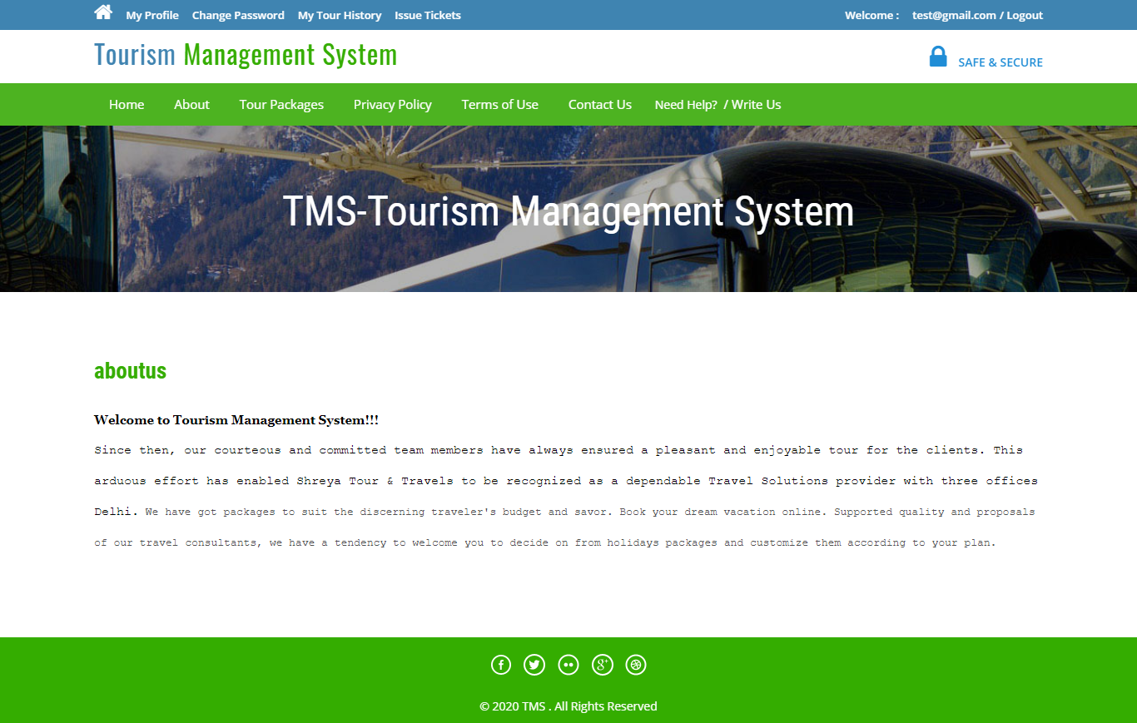

**Contact Us Page**

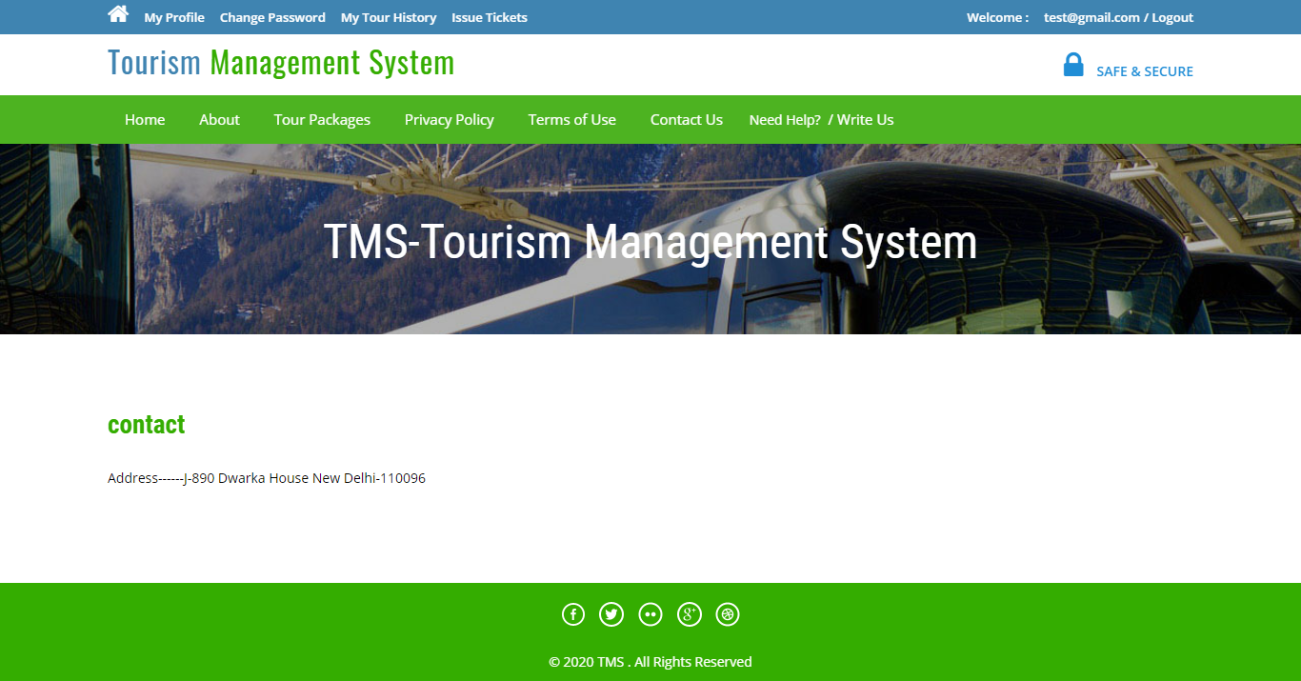

**Travels Packages**

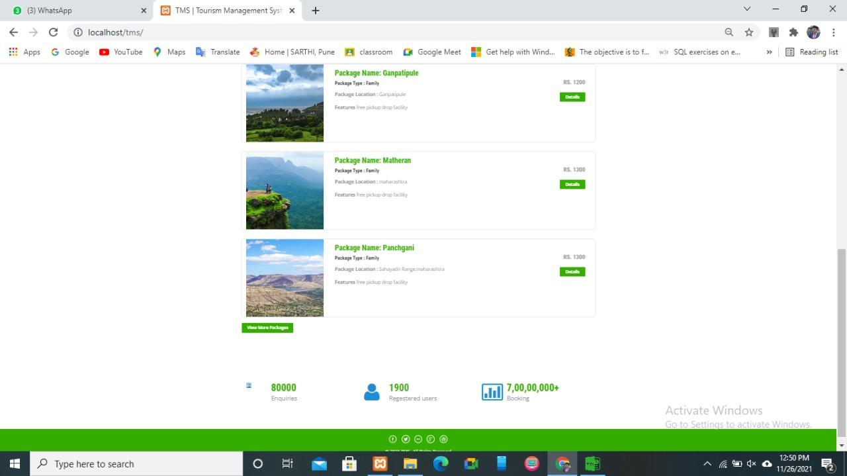

**Privacy Policy**

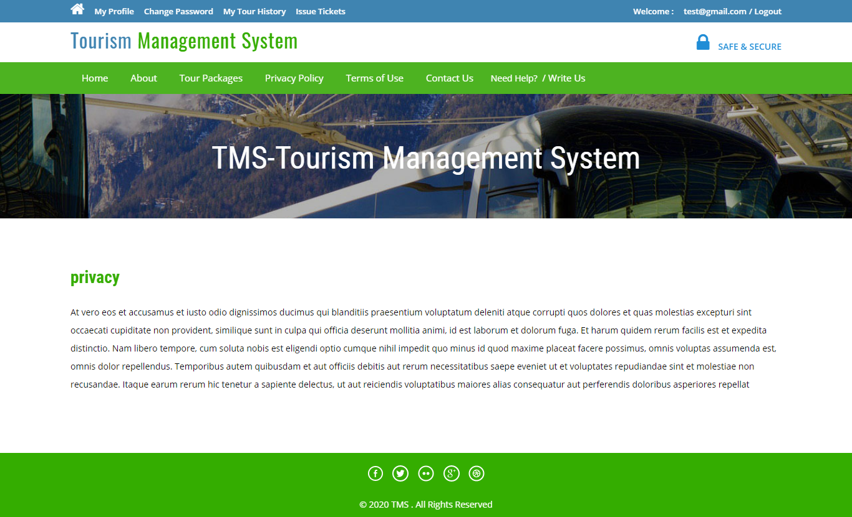

**Need Help Page**

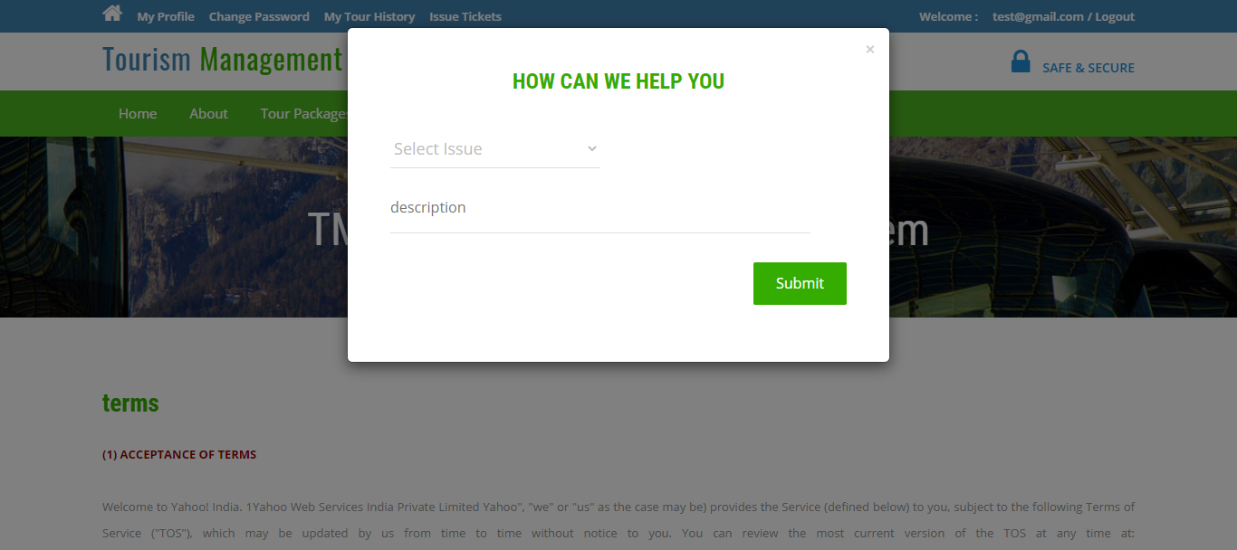

**User Profile**

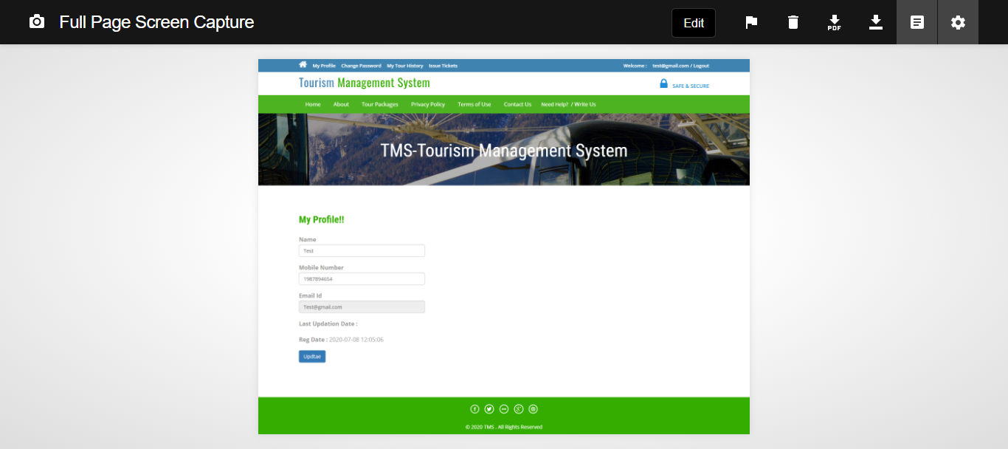

**Change Password**

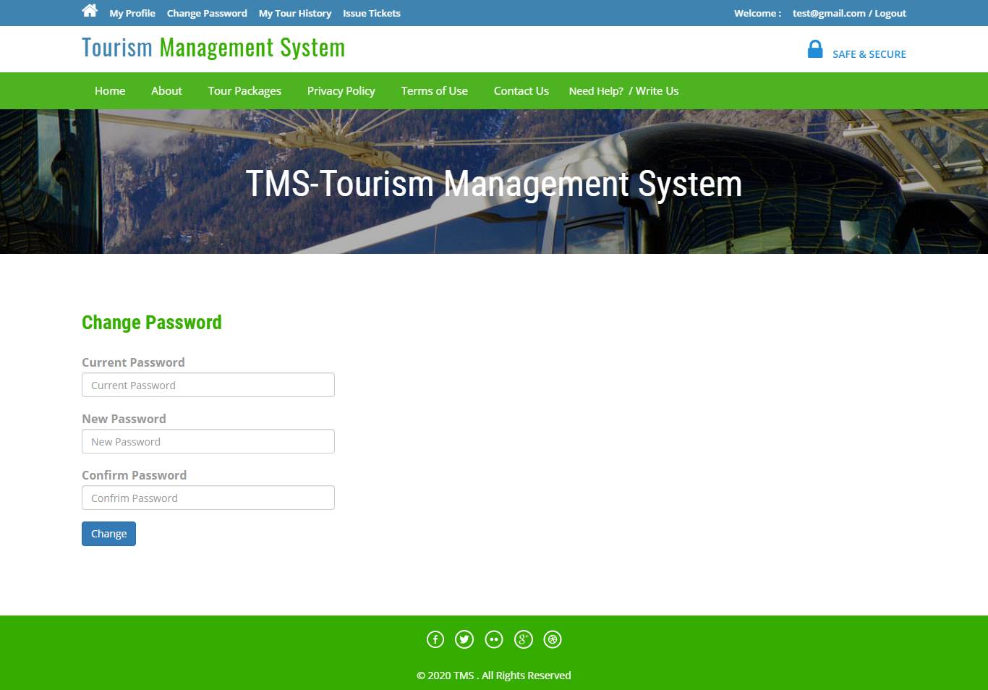

**User Tour History**

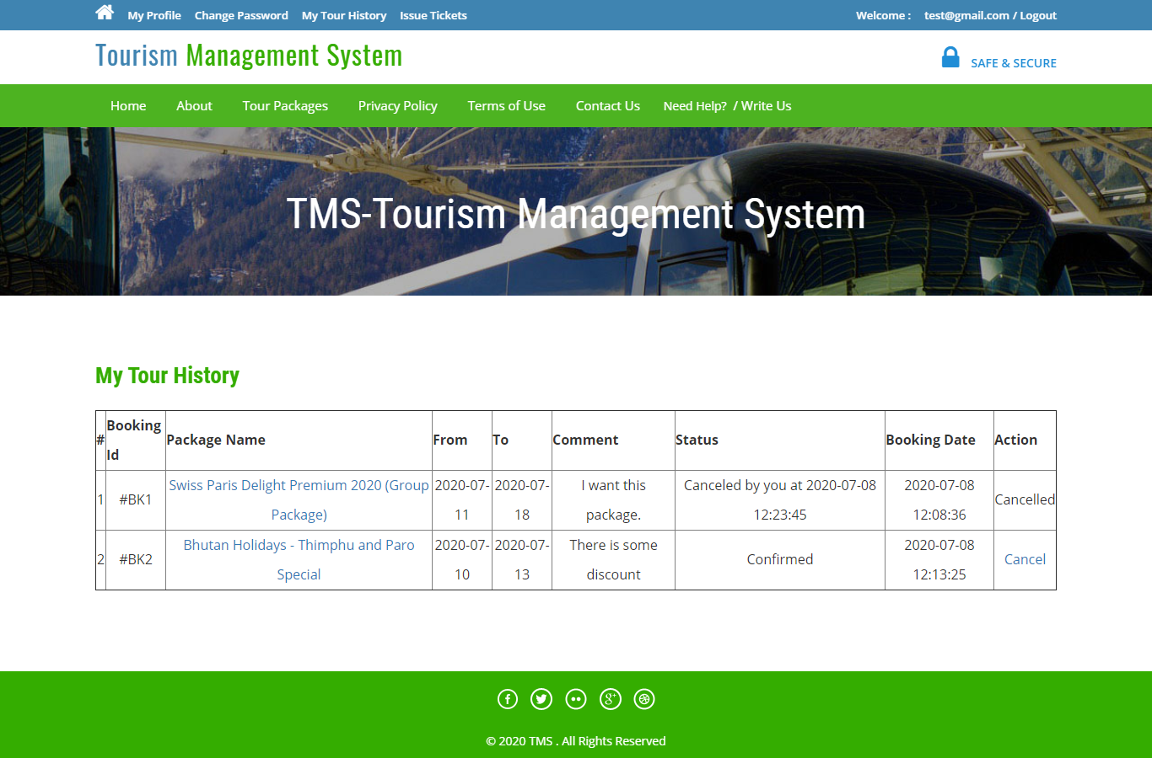

**User Issue Tickets**

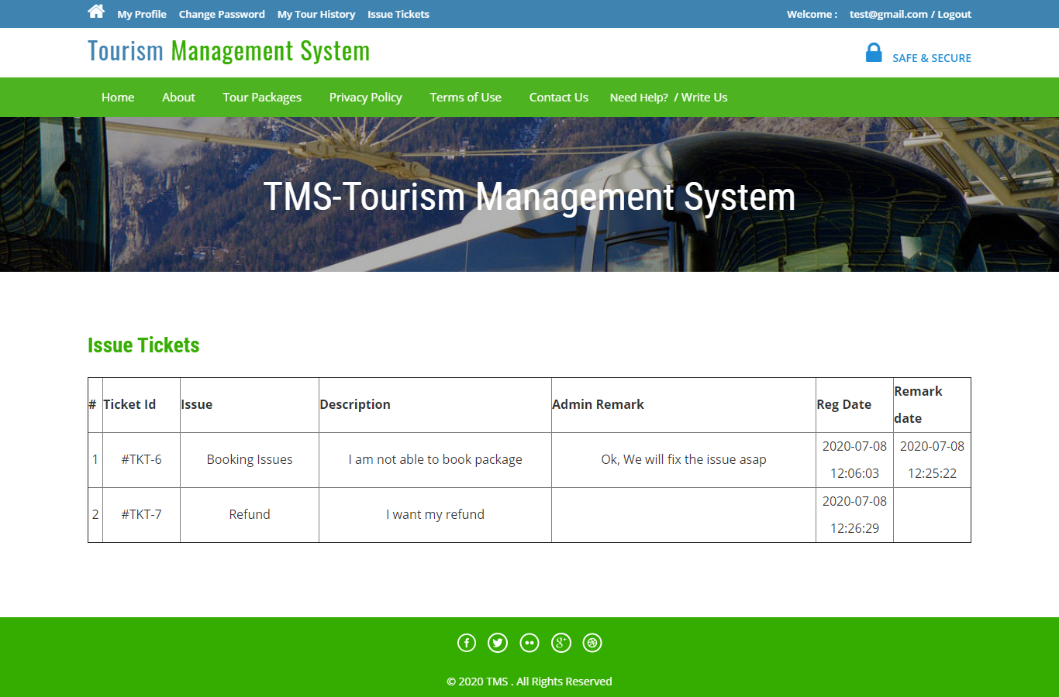

**User Sign in**

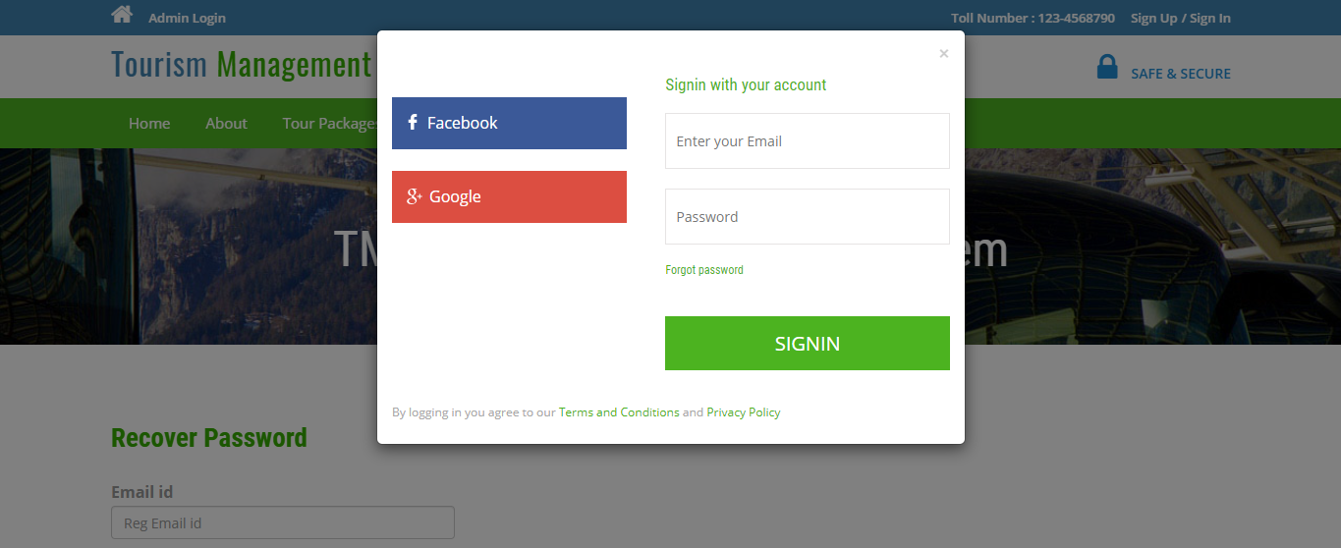

**Forgot Password**

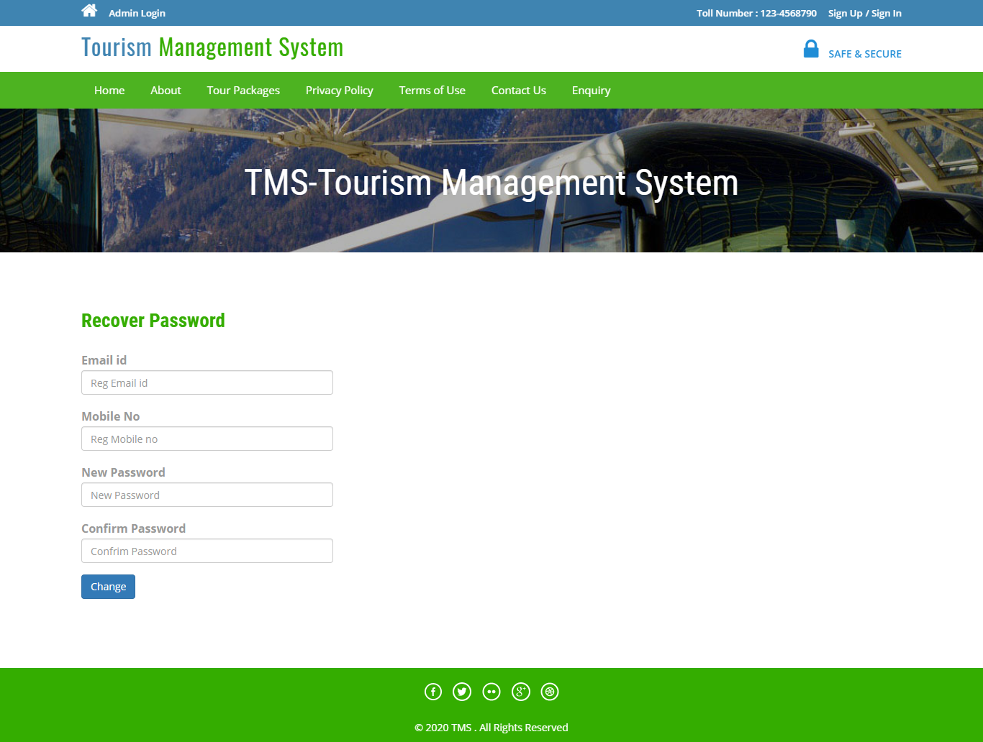

**Admin Login**

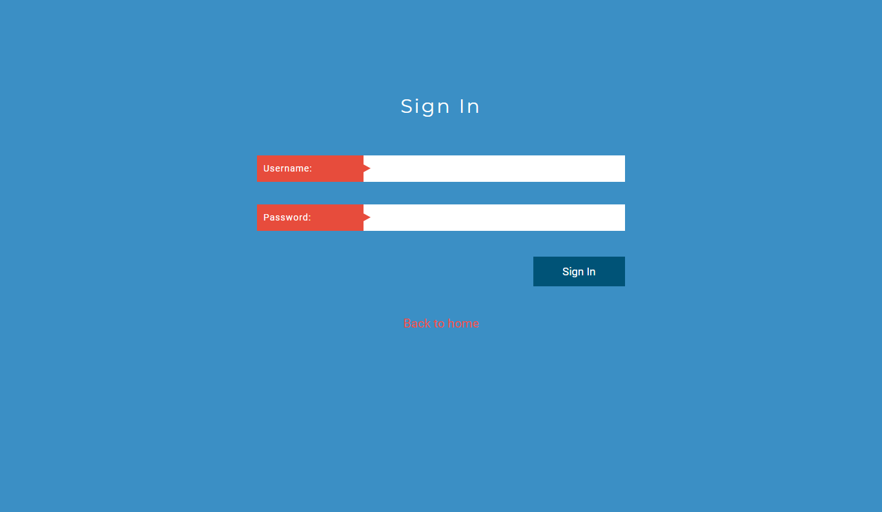

**Dashboard**

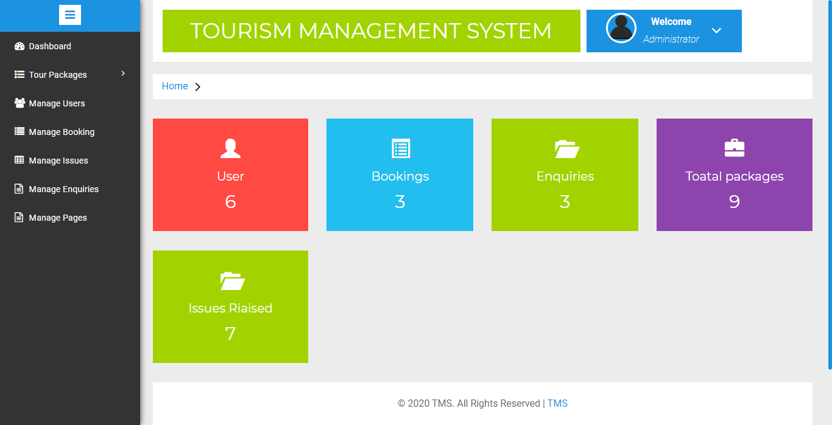

**Update Image**

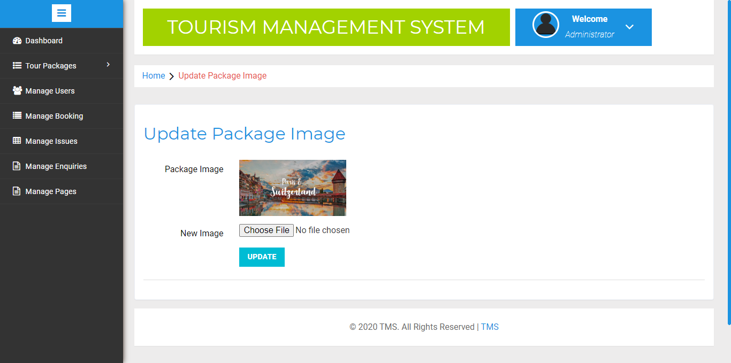

**Manage Users**

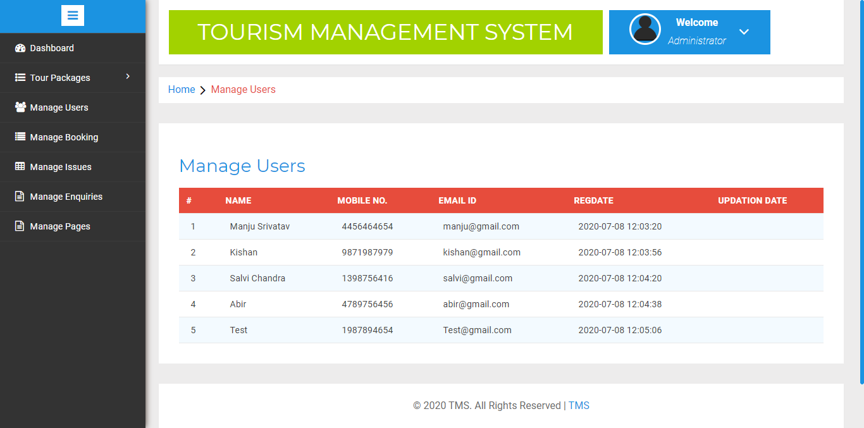

**Manage Booking**

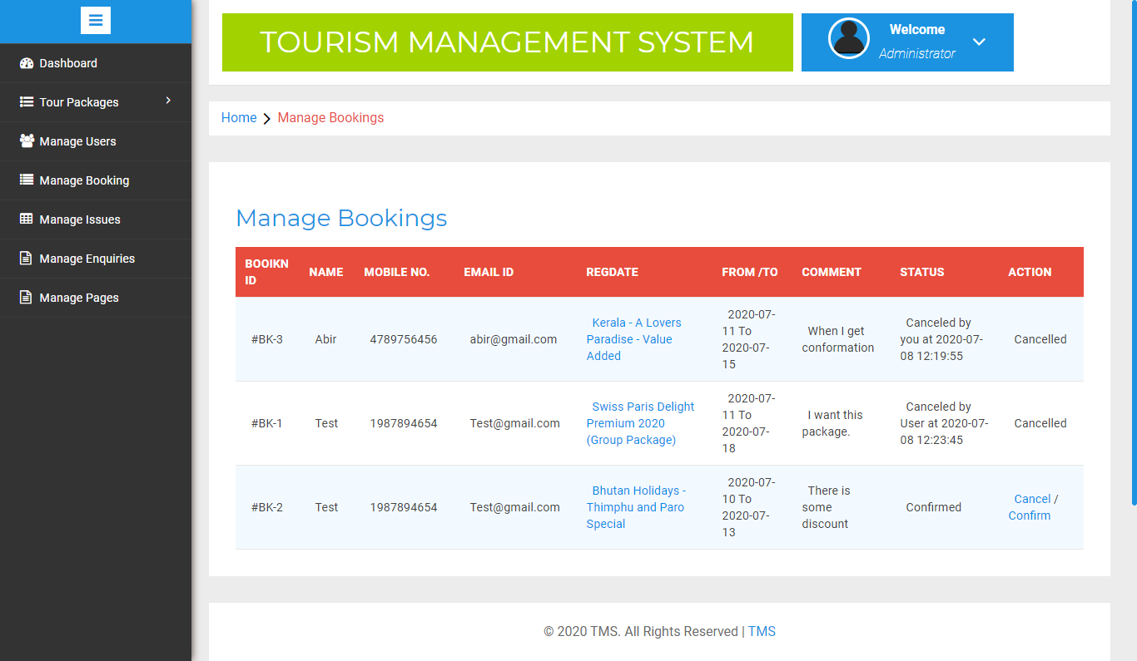

**Manage Issues**

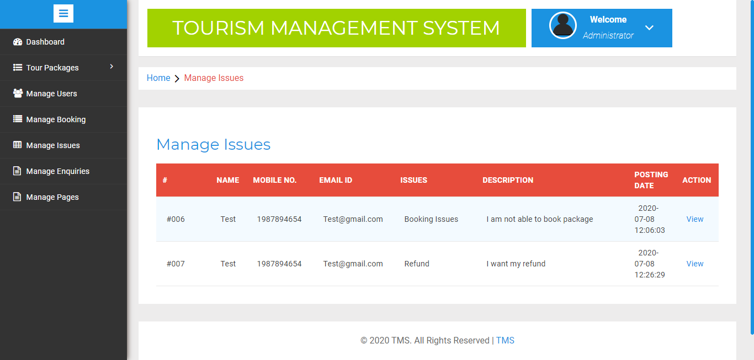

**Manage Enquiry**

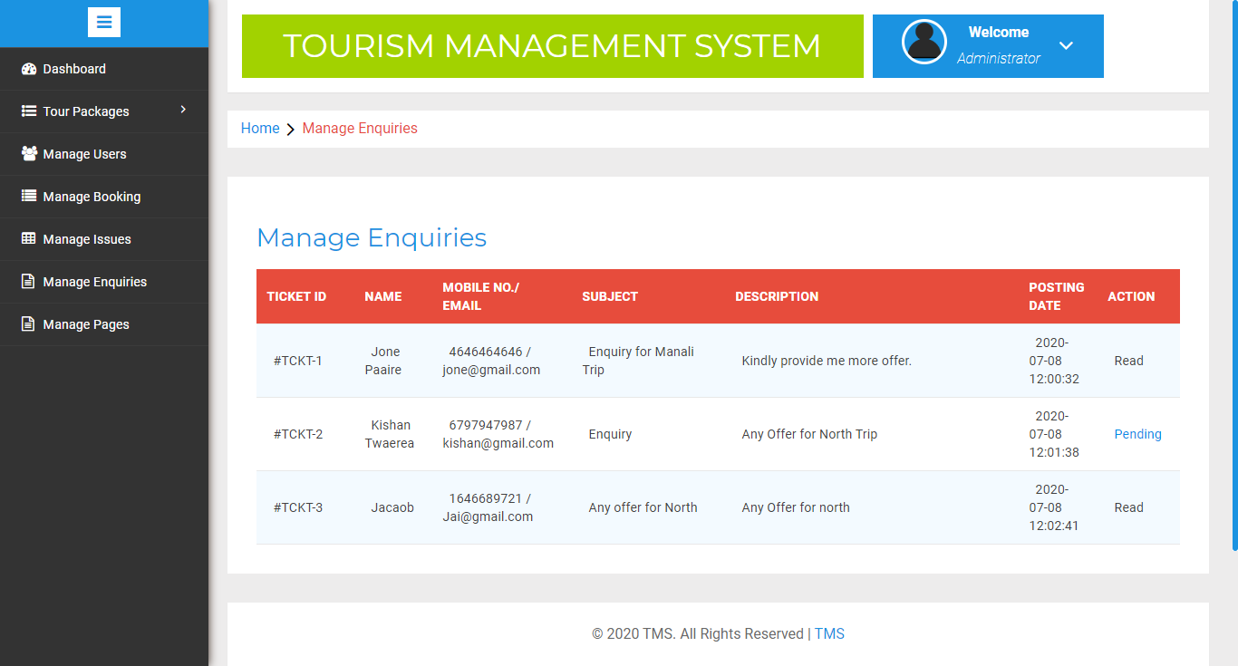

**Manage Pages**

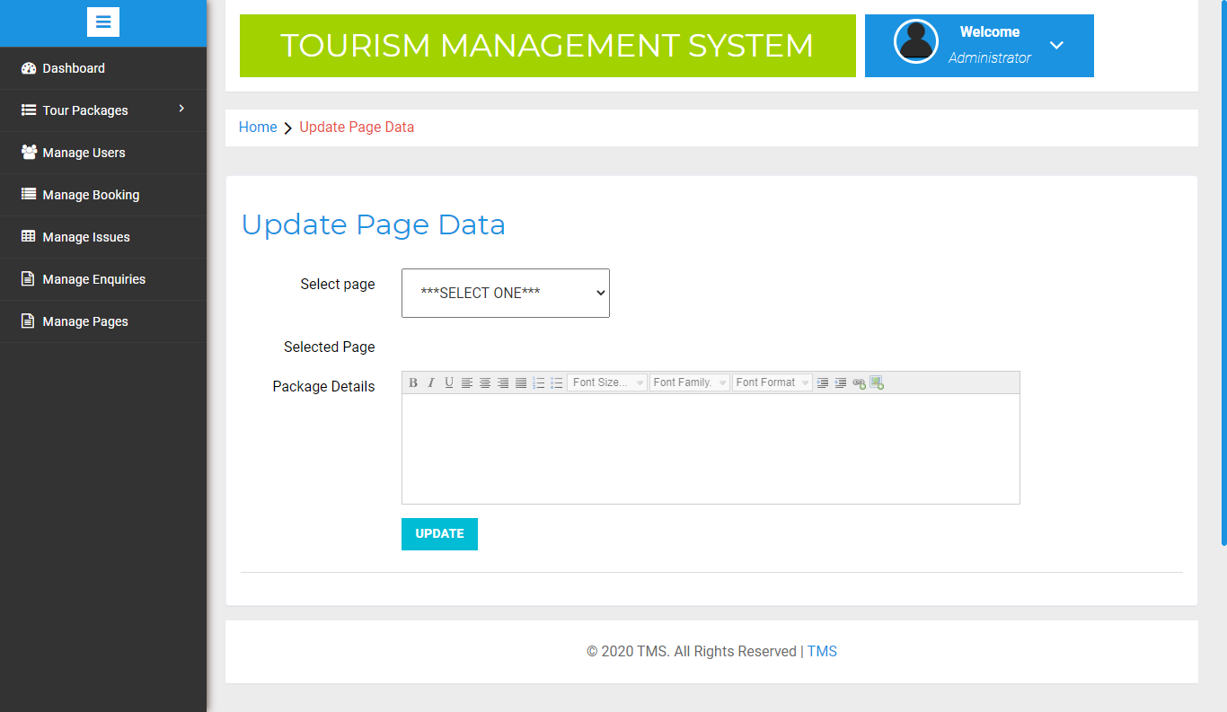

**Change Password**

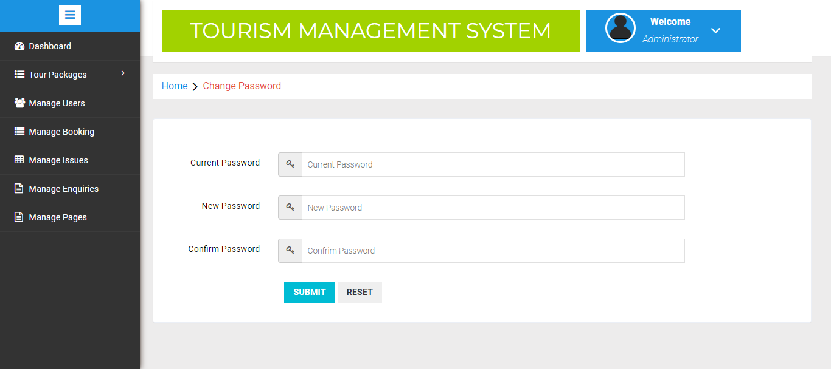

**CONCLUSION**

* This web application was successfully created and stored all the admin tourism packages booking, creation managing and tour details into the database using this application.
* The application was tested very well and the errors were properly debugged. Testing also concluded that the performance of the system is satisfactory. All the necessary output is generated.

* This system thus provides an easy way to automate all the functionalities of consumption. If this application is implemented in few consumption, it will be helpful.

* Further enhancements can be made to the project, so that the website functions in a very attractive and useful manner than the present one. It is concluded that the application works well and satisfy the needs. The application is tested very well and errors are properly debugged.

**BIBILIOGRAPHY**

1. www.w3schools.com
2. in.**php**.net
3. en.wikipedia.org/wiki/**PHP**
4. www.hotscripts.com/category/**php**/
5. www.**apache**.org
6. www.**mysql**.com